Here's a question related to the provided code:

**Question:** In the Java program, two classes, `Icecream.java` and `Test.java`, are defined. The `Icecream` class represents ice cream with attributes like type, company, and price, and it includes a method for checking equality. The `Test` class creates two ice cream objects and compares them. Explain the structure and purpose of the `Icecream` class, and describe what happens when you create `I1` and `I2` ice cream objects and call the `equals` method. What will be the output of the `System.out.println(I1.equals(I2));` statement in the `Test` class?

Answer:
- The `Icecream` class stores information about ice cream, including type, company, and price. It has a `tostring` method for generating a string representation and an `equals` method to check if two ice cream objects are equal based on their attributes.
- In the `Test` class, two `Icecream` objects, `I1` and `I2`, are created with the same type, company, and price.
- The `equals` method of the `Icecream` class is called to compare `I1` and `I2` attributes.
- The output of `System.out.println(I1.equals(I2));` will be `true` because `I1` and `I2` have the same type, company, and price, making them equal according to the `equals` method.

Lesson for this code:

1. toString() method

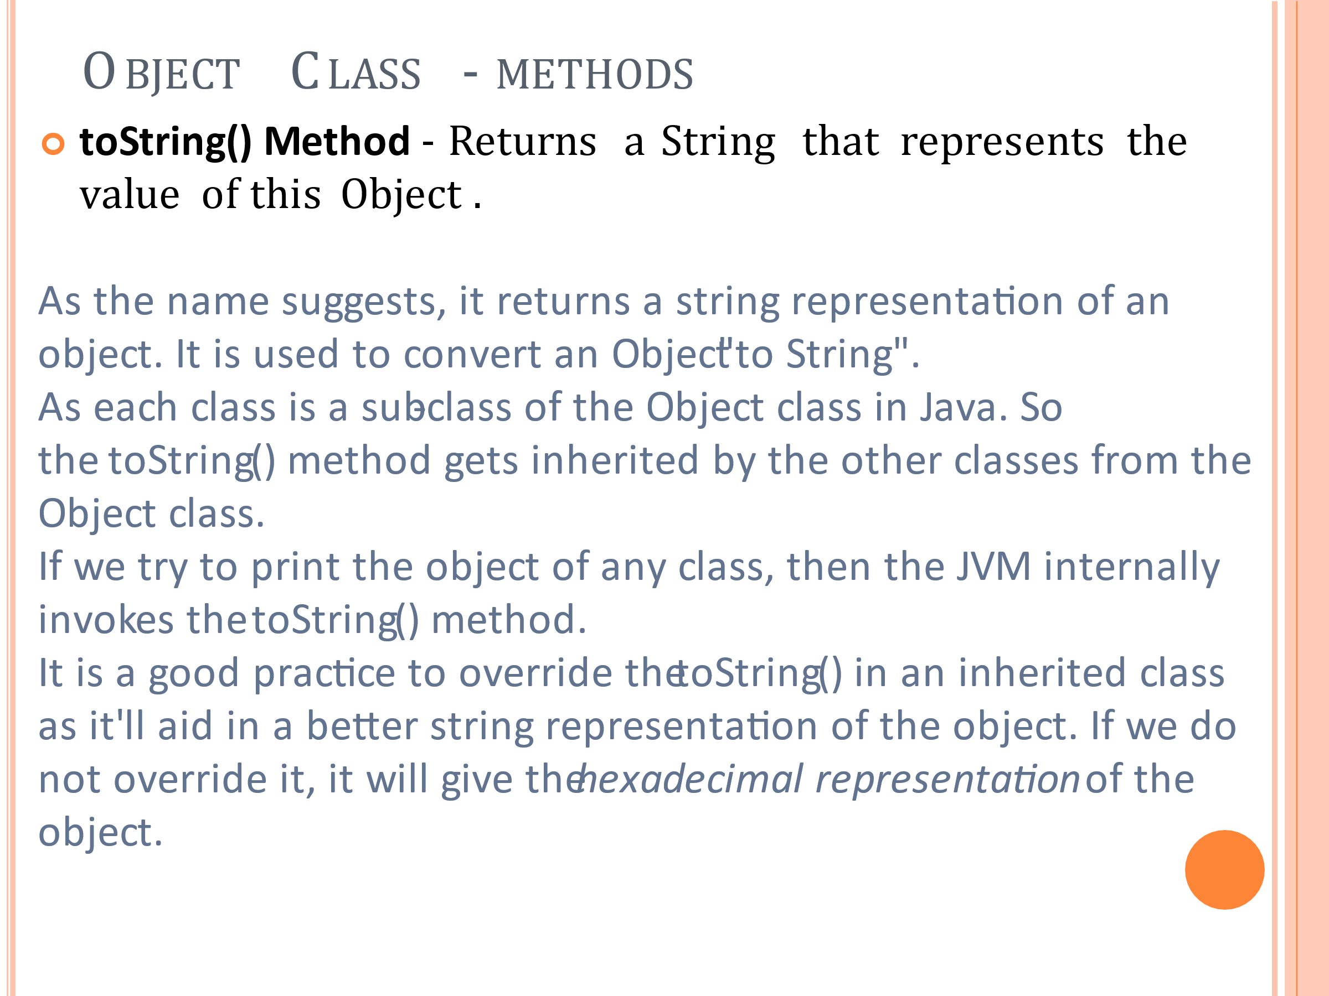

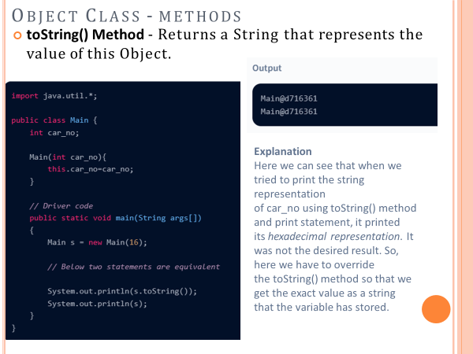

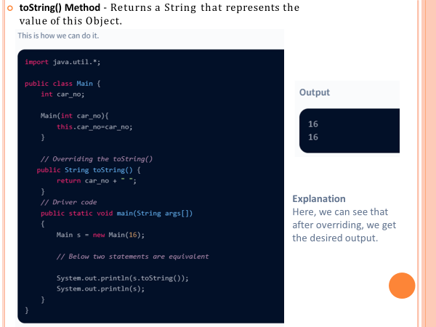

2. equals(Object obj) method
It compares the given object to “this” object (the object on which the method is called). It gives a generic way to compare objects for equality. It is recommended to override the equals(Object obj) method to get our own equality condition on Objects.
For more on the override of equals(Object obj) method refer – Overriding equals method in Java
Note: It is generally necessary to override the hashCode() method whenever this method is overridden, so as to maintain the general contract for the hashCode method, which states that equal objects must have equal hash codes.

For Further Reading:
Object Class in Java - Scaler Topics
Object Class in Java - GeeksforGeeks
Java Object Class - Javatpoint
Object Cloning in java - Javatpoint

